Pre Calc Name: ______________

______________ ______________

WS Assessment

Target 11

Linear systems of equations

* Solving Linear System by Substitution and Matrix
* Applications of Equations
* Linear programming

HW 11 Linear System www.deltamath.com

Solving linear equations by substitution

2x + 3y + z = 17 7x + 9y = 38 2y = 5x – 7

2y – 3z = 20 x = 4 – y 4x = 2y – 10

z = -6

Redo the above by matrix method (show matrix set up) [A]-1[B] = [X}

Maricopa's Success scholarship fund receives a gift of $ 200000. The money is invested in stocks, bonds, and CDs. CDs pay 5 % interest, bonds pay 5.7 % interest, and stocks pay 12 % interest. Maricopa Success invests $ 30000 more in bonds than in CDs. If the annual income from the investments is $ 15460 , how much was invested in each account? (Both ways)

Andrea sells photographs at art fairs. She prices the photos according to size: small photos cost $10, medium photos cost $15, and large photos cost $40. She usually sells as many small photos as medium and large photos combined. She also sells twice as many medium photos as large. A booth at the art fair costs $300. If her sales go as usual, how many of each size photo must she sell to pay for the booth? (Both ways)

Application of linear equations (most common)

Traffic flow Current in loop circuit

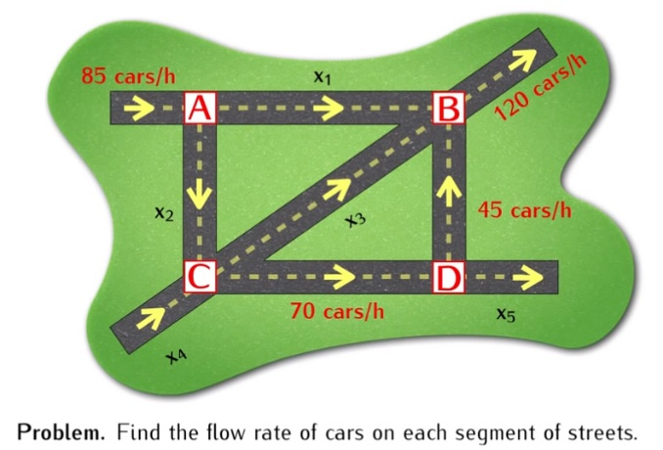 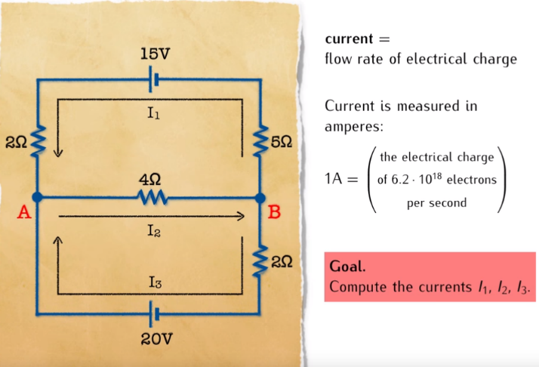

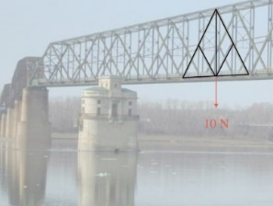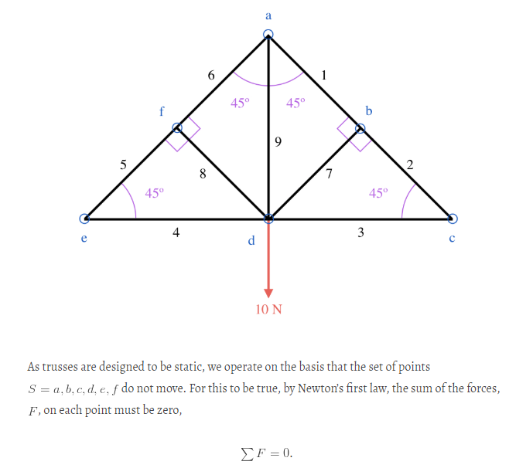 Balancing chemical reaction Truss problem

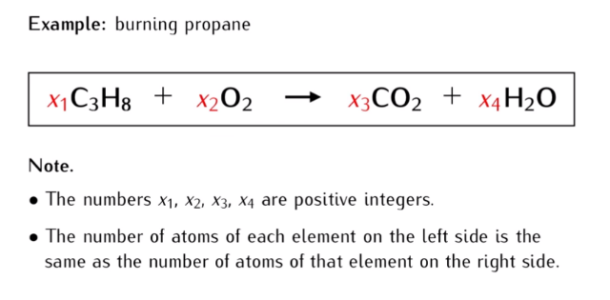

Linear programming

 A farmer has 10 acres to plant in wheat and rye. He has to plant at least 7 acres. However, he has only $1200 to spend and each acre of wheat costs $200 to plant and each acre of rye costs $100 to plant. Moreover, the farmer has to get the planting done in 12 hours and it takes an hour to plant an acre of wheat and 2 hours to plant an acre of rye. If the profit is $500 per acre of wheat and $300 per acre of rye how many acres of each should be planted to maximize profits?

 A gold processor has two sources of gold ore, source A and source B. In order to kep his plant running, at least three tons of ore must be processed each day. Ore from source A costs $20 per ton to process, and ore from source B costs $10 per ton to process. Costs must be kept to less than $80 per day. Moreover, Federal Regulations require that the amount of ore from source B cannot exceed twice the amount of ore from source A. If ore from source A yields 2 oz. of gold per ton, and ore from source B yields 3 oz. of gold per ton, how many tons of ore from both sources must be processed each day to maximize the amount of gold extracted subject to the above constraints?

A publisher has orders for 600 copies of a certain text from San Francisco and 400 copies from Sacramento. The company has 700 copies in a warehouse in Novato and 800 copies in a warehouse in Lodi. It costs $5 to ship a text from Novato to San Francisco, but it costs $10 to ship it to Sacramento. It costs $15 to ship a text from Lodi to San Francisco, but it costs $4 to ship it from Lodi to Sacramento. How many copies should the company ship from each warehouse to San Francisco and Sacramento to fill the order at the least cost?

The West Hartford Senior Center is trying to establish a transportation system of small and large vans. It can spend no more than $100,000 for both sizes of vehicles and no more than $500 per month for maintenance. The WHSC can purchase a small van, which carries up to 7 passengers, for $10,000 and maintain it for $100 per month. The large vans, which carry up to 15 passengers, cost $20,000 each and can be maintained for $75 per month. How many of each type of van should they purchase if they want to maximize the number of passengers?

**Air speed**: The speed of the airplane through still air (including units)

**Wind speed**: The speed of the wind relative to the ground (including units)

**Tail wind**: A wind blowing in the same direction as the one in which the plane is heading

**Head wind**: A wind blowing in the direction opposite to the one in which the airplane is

heading.

**Ground Speed**: The speed of the airplane relative to the ground

With a tail wind: ground speed = air speed + wind speed

With a head wind: ground speed = air speed - wind speed

With a tail wind, a light plane can fly ______ in _____ hours.

Going against the wind, the plane can fly the same distance in ______ hours.

What are the ground speed, wind speed and the air speed of the plane?

**Target 11 Assessment**

I have $ ________.____ comprised of nickels, dimes and quarters. I have _________ as many dimes as quarters and _________ there are ________ (more or less) nickel than dimes. How many of each do I have?

 Amounts of a 35% alcohol solution and a 65% alcohol solution are to be mixed to produce 24 gallons of a 45% alcohol solution. How many gallons of the 35% alcohol solution and how many gallons of the 65% alcohol solution should be used?

Bountiful Boats has to produce at least **5000** cabin cruisers and **12,000** pontoons each year; they can produce at most **30,000** jet skis in a year. The company has two factories:  one in Michigan, and one in Wisconsin; each factory is open for a maximum of **240**days per year. The Michigan factory makes **20** cabin cruisers, **40** pontoons, and **60** jet skis per day. The Wisconsin factory makes **10**cruisers, **30** pontoons, and **50** jet skis per day. The cost to run the Michigan factory per day is **$960,000**; the cost to run the Wisconsin factory per day is **$750,000**. **How many days of the year should each factory run in order to meet the boat production, yet do so at a minimum cost?**